EL SALVADOR

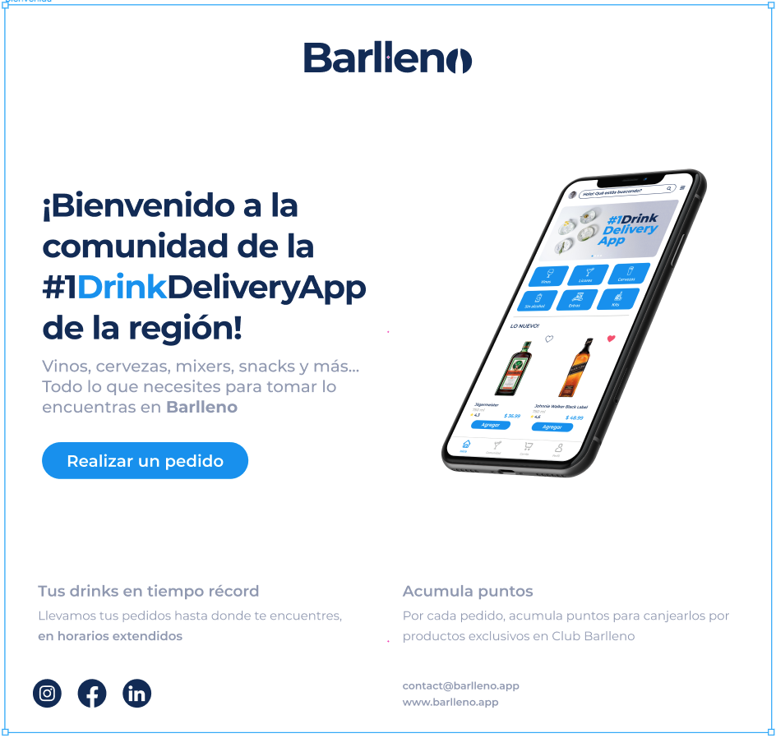

Links:

Instagram:

<https://www.instagram.com/barlleno/>

Facebook:

<https://www.facebook.com/barlleno/>

Linkedin:

<https://sv.linkedin.com/company/barlleno>

GUATEMALA



Links:

Instagram:

<https://www.instagram.com/barlleno.app/>

Facebook:

<https://www.facebook.com/BarllenoGT/>

Linkedin:

<https://sv.linkedin.com/company/barlleno>

COLOMBIA



Links:

Instagram:

<https://www.instagram.com/barlleno.co/>

Facebook:

<https://m.facebook.com/barlleno.co/>

Linkedin:

<https://sv.linkedin.com/company/barlleno>

RD

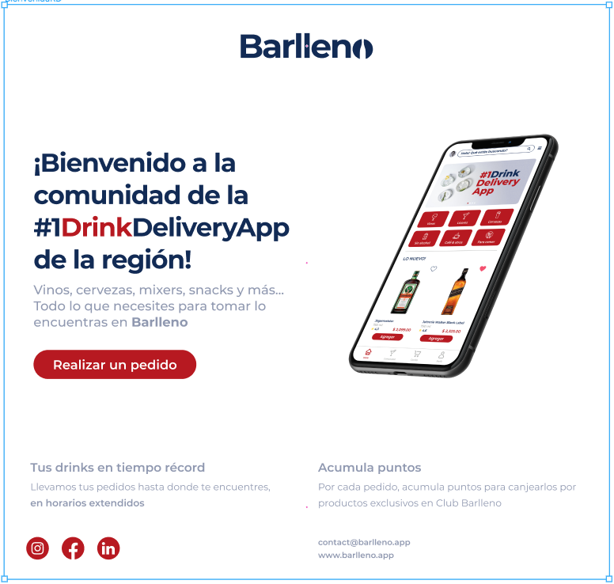

Links:

Instagram:

<https://www.instagram.com/barllenord/>

Facebook:

<https://www.facebook.com/Barllenord/>

Linkedin:

<https://sv.linkedin.com/company/barlleno>